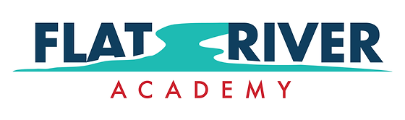

Flat River Academy Board of Directors

Regular Meeting

Wednesday, January 15, 2025 6:30 p.m.

AGENDA

1. Call to Order and Roll Call
2. Pledge of Allegiance
3. Approval of Agenda
4. Approval of December 18, 2024 Regular Minutes
5. New Business
6. Old Business
7. Principal’s Report
8. Midwest School Services
   1. December 2024 Financials
   2. 24-25 Budget Amendment
9. Extended public comments on non-agenda item
10. Board Comments
11. Reconfirmation of Next Meeting Date:

February 19, 2024 at 6:30 p.m. at Flat River Academy

1. Adjournment

*Individuals wishing to address the Board of Directors under public comment above are requested to sign in with the Board Secretary prior to the start of the meeting. Individual comments are limited to not more than three (3) minutes each and a total time allowance not to exceed thirty (30) minutes. The Board may not verbally respond to public comments but may follow up in the most appropriate and time-effective manner.*

*Individuals with special need accommodations should contact the principal’s office at 6167549360 preferably one (1) business day prior to the meeting.*

*Proposed minutes of this meeting will be available for public inspection at the Flat River Academy Office located at Jordan Rd eight (8) business days after the meeting. Approved minutes are available within five (5) business days after the meeting at which they are approved. (Open Meetings Act, Public Act 267)*